Rooftop Solar Energy Monitor

import java.io.*;
import java.nio.file.*;
import java.util.*;
import java.util.stream.*;

// ==========================================
// MODULE 4: OOP, Encapsulation & toString()
// ==========================================
class SolarReading implements Comparable<SolarReading> {
private String timestamp; // Module 5: String abstraction
private double powerOutput; // in kilowatts

public SolarReading(String timestamp, double powerOutput) {
this.timestamp = timestamp;
this.powerOutput = powerOutput;
}

public double getPowerOutput() { return powerOutput; }
public String getTimestamp() { return timestamp; }

@Override
public String toString() {
return timestamp + " : " + powerOutput + " kW";
}

// MODULE 5: Comparable interface for ordering objects
@Override
public int compareTo(SolarReading other) {
return Double.compare(this.powerOutput, other.powerOutput);
}
}

class SolarEnergyMonitor {
// MODULE 6: Collections Framework (List, Map) & Generics
private List<SolarReading> readings;

public SolarEnergyMonitor() {
this.readings = new ArrayList<>();
}

public void addReading(SolarReading reading) {
readings.add(reading);
}

public List<SolarReading> getReadings() {
return readings;
}

// MODULE 3: Summation & Average techniques
public double totalEnergy() {
return readings.stream()
.mapToDouble(SolarReading::getPowerOutput)
.sum();
}

public double averagePower() {
return readings.stream()
.mapToDouble(SolarReading::getPowerOutput)
.average()
.orElse(0.0);
}

// MODULE 6: Stream Pipelines (max, filter, collect)
public Optional<SolarReading> peakPower() {
return readings.stream()
.max(Comparator.comparingDouble(SolarReading::getPowerOutput));
}

// MODULE 3: Recursion example (e.g., recursive count of readings above threshold)
public int countAboveThreshold(double threshold, int index) {
if (index >= readings.size()) {
return 0;
}
int count = (readings.get(index).getPowerOutput() > threshold) ? 1 : 0;
return count + countAboveThreshold(threshold, index + 1);
}

// MODULE 6: Collectors (groupingBy for advanced reports)
public Map<Boolean, List<SolarReading>> partitionByPerformance(double threshold) {
return readings.stream()
.collect(Collectors.partitioningBy(r -> r.getPowerOutput() >= threshold));
}

public void displayReadings() {
readings.forEach(System.out::println);
}
}

public class RooftopSolarMonitorApp {

// MODULE 4: Exception Handling using 'throws'
public static void main(String[] args) throws IOException {
// MODULE 1: Console I/O with Scanner & Primitive variables
Scanner scanner = new Scanner(System.in);
SolarEnergyMonitor monitor = new SolarEnergyMonitor();

System.out.println("Enter solar panel readings (<timestamp> <powerOutput>). Type 'end' to finish:");

// MODULE 2: Control Flow (while loop, break, continue, if-else)
while (true) {
try {
String input = scanner.nextLine();

// MODULE 5: String comparison and manipulation (equalsIgnoreCase, trim, split)
if (input.equalsIgnoreCase("end")) {
break;
}

String[] parts = input.trim().split("\\s+");
if (parts.length != 2) {
System.out.println("Invalid input format. Use: <timestamp> <powerOutput>");
continue; // Module 2: continue statement
}

String timestamp = parts[0];
// MODULE 1: Typecasting / parsing wrapper classes
double powerOutput = Double.parseDouble(parts[1]);

monitor.addReading(new SolarReading(timestamp, powerOutput));

} catch (NumberFormatException e) {
// MODULE 4: Exception handling (try-catch block)
System.out.println("Invalid power value. Please enter a numeric value.");
} finally {
// MODULE 4: try-catch-finally block demonstration
// (Cleanup or execution tracking can go here)
}
}

// Display basic results using formatted printing (Module 1)
System.out.println("\n--- Solar Panel Energy Readings ---");
monitor.displayReadings();

System.out.printf("Total Energy Generated: %.2f kW\n", monitor.totalEnergy());
System.out.printf("Average Power Output: %.2f kW\n", monitor.averagePower());

monitor.peakPower().ifPresent(p -> System.out.println("Peak Power Output: " + p));

// ==========================================
// MODULE 5 & 6: File I/O & File Streams
// ==========================================
Path filePath = Paths.get("solar_report.txt");

// Writing text files using modern java.nio.file APIs & try-with-resources
try (BufferedWriter writer = Files.newBufferedWriter(filePath)) {
writer.write("=== SOLAR MONITOR REPORT ===\n");
for (SolarReading r : monitor.getReadings()) {
writer.write(r.toString() + "\n");
}
writer.write("Total: " + monitor.totalEnergy() + " kW\n");
System.out.println("\nSuccessfully saved report to file: " + filePath.toAbsolutePath());
} catch (IOException e) {
System.out.println("Error writing to file: " + e.getMessage());
}

// Reading file lines back as a stream (Module 6 feature)
System.out.println("\n--- Reading file lines back using Stream API ---");
try (Stream<String> lines = Files.lines(filePath)) {
lines.limit(4).forEach(System.out::println);
}

scanner.close();
}
}

OUTPUT

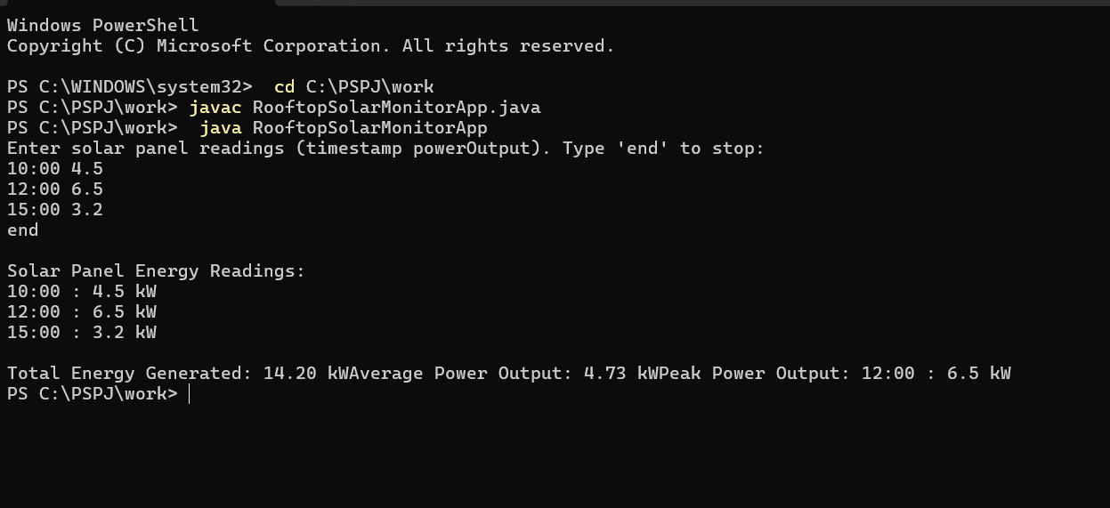

1. Abstract
The Rooftop Solar Energy Monitor is a Java-based software application designed to track, calculate, and analyze power generation metrics from residential and commercial rooftop solar panel arrays. With the growing adoption of renewable solar energy, continuous monitoring is critical to ensure optimal panel efficiency, fault detection, and energy yield management. Built using core Java concepts, object-oriented programming (OOP), file handling, and the Java Stream API, this application accepts time-series power output data (in kilowatts) and dynamically computes key performance indicators such as total energy generated, average output, and peak generation times. Additionally, the system persists performance summaries into structured report files (solar_report.txt) for historical auditing. By automating solar data logging and metrics calculation, the software simplifies energy usage analysis for users and promotes sustainable energy management.

2. Advantages of the Solar Rooftop Energy Monitor
Real-time Performance Insights: Allows users to dynamically input timestamped power readings and instantly evaluate real-time total, average, and peak power statistics.
Automated Data Persistence: Saves report logs directly to text files using Java's modern File I/O (nio package), eliminating manual record-keeping errors.
Efficiency Monitoring & Fault Detection: Helps operators quickly identify dropped power outputs or efficiency losses compared to peak performance thresholds.
Cost & Energy Optimization: Provides data required to track daily power yields, allowing consumers to maximize self-consumption and minimize grid electricity costs.
Robust Error Handling: Built with input validation and exception handling (try-catch blocks) to prevent system crashes caused by malformed user inputs or invalid numeric data.
Modular and Lightweight: Written in core Java without requiring heavy external dependencies, making it execution-ready across cross-platform environments via command-line terminals like PowerShell.

3. Conclusion
The Rooftop Solar Energy Monitor successfully demonstrates how object-oriented computational tools can be applied to solve real-world problems in renewable energy management. By integrating fundamental programming techniques—such as encapsulated classes, collection structures (ArrayList), file operations, exception handling, and functional Java Streams—the project delivers a complete software workflow from data input to report generation. The application fulfills key evaluation metrics for computer science coursework while serving as a functional prototype for monitoring rooftop solar array performance.
4. Future Works
IoT Hardware Integration: Connect the software with physical sensors (e.g., ESP32/Arduino microcontroller platforms) via serial communication or APIs to collect real-time voltage, current, and light intensity data automatically.
Database & Cloud Storage Integration: Replace local text file logging with relational databases (e.g., MySQL, PostgreSQL) or cloud databases (e.g., Firebase) for scalable historical trend tracking.
Graphical User Interface (GUI): Enhance user experience by transitioning from console input to a desktop GUI (using JavaFX or Swing) or a web interface featuring interactive graphs and charts.
Predictive Analytics & Weather Forecasting: Incorporate machine learning models to analyze weather API data and predict daily solar yield based on cloud cover, temperature, and seasonal sunlight hours.
Automated Failure Alerts: Implement automated email or SMS notifications (using JavaMail or Twilio APIs) to alert panel owners immediately if power generation drops below an expected threshold during daylight hours.07:28 PM

